ENDOUROLOGY INTERNATIONAL TRAVEL SCHOLARSHIP 2023; EXPERIENCE AT UCSF

My quest for clinical experience and mentorship in endourology was the drive for my desire to get this scholarship. I had two main objectives which were to learn the basic principles of anatomical enucleation of the prostate using a holmium laser and also percutaneous nephrolithotomy. I found myself extremely lucky to be accepted to the program at UCSF by Marshall Stoller and Thomas Chi because both professors are involved in these procedures and much more.
My training was from the 8th of January 2024 to 8th of February 2024. I was warmly welcomed by members of the Endourology team. I was able to complete the required documentation and obtained my ID for access to the operating theatre with no hassles. I was graciously given unlimited access to the operating theatres to join a case that is of interest to me including non-endourological cases. This was impressive.
I was able to observe 8 Holmium laser enucleations of the prostate during the period. The peculiarities of patient positioning in HOLEP were illustrated as well as the required hand instruments, laser machine, laser fiber, and laser settings. I was taught the early apical release technique with the ideal approach to the identification of external urethral sphincter, mucosal strips, and planes of dissection during enucleation. The morcellation techniques were not left out and the important safety tips were well spelt out.
I was opportune to observe 12 percutaneous nephrolitotomies 8 were supine and 4 were prone. All were ultrasound-guided procedures. I had hands-on training in ultrasound-guided puncture and tract dilation. There were numerous ureteroscopies with laser lithotripsy and also endoscopic combined intrarenal surgeries. Ambulatory surgical procedures during my stay were largely stent changes, transurethral resection of bladder tumors, urolift insertions, and HOLEP.
Lapararosopic nephrectomies, pyeloplasties, and ureteric re-implantation were performed at some point during my stay at UCSF. There was also a robotic-assisted nephrectomy as well as a robotic-assisted pyeloplasty.
I was able to gather some soft skills in communication with the patients and relationships with colleagues during my observation with Dr Thomas Chi at the urology outpatient clinics. I observed his response to unusual situations with patients as well as his ability to explain the disease process, options of treatment, side effects from treatment, and ultimately having a shared decision with the patients. I also imbibed leadership and mentoring skills while observing his relationships with residents and endourology fellows.
Finally, my mentors at UCSF gave me a good platform to research by allowing me to join the research meetings of the team. I was encouraged to generate good research questions, hypotheses, and study designs.
I had a few challenges which I was able to overcome during my stay. Notably was the change in weather, I had no experience with the extent of cold in San Francisco. I however got used to it by the second week of my stay.
I would conclude with words of appreciation to the Endourology Society for giving me this unique lifetime opportunity to meet and learn from amazing mentors and colleagues at UCSF. Surely the lessons I learned will improve my practice and I hope to strengthen my relationship with UCSF through education, research, and collaboration.
I would like to say Thank you to Thomas Chi and Marshall Stoller for the warm welcome and wonderful mentoring.
I would also like to thank Prof Ahmed Muhammed of my institution in Nigeria and his colleagues for their continued mentorship to ensure I have good clinical exposure and practice.
Thank you.
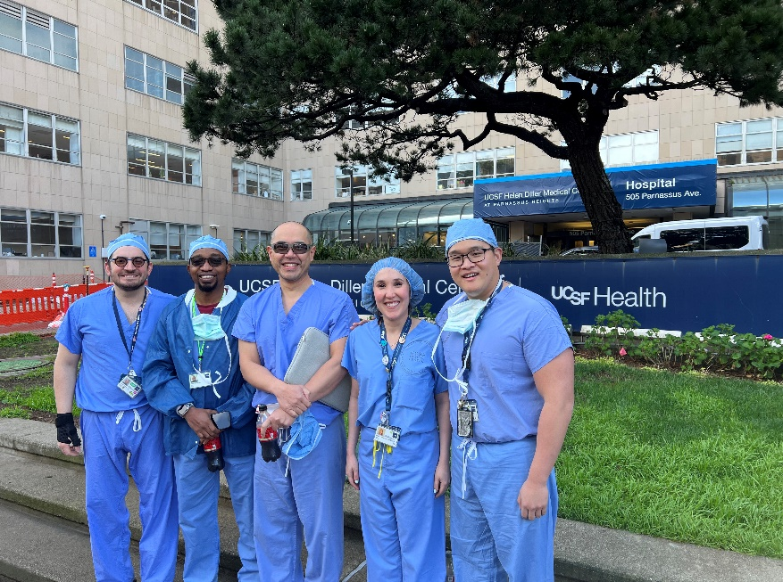

DR NASIR OYELOWO MBBS FWACS
Senior Lecturer/ Consultant Urologist
Ahmadu Bello University Zaria, Nigeria

